
Superior University
Department Of Software Engineering

Project Name :
Car Rental System
Subject :
Object Oriented Programming
Section :
BSSE-2B
Name : Muhummad Sami Abid Roll No : SU92-BSSEM-F24-117
Name : Muhummad Ahsan Iqbal Roll No : SU92-BSSEM-F24-134
Name : Abdul Rehman Gallani Roll No : SU92-BSSEM-F24-100
Name : Muhummad Asim Yameen Roll No : SU92-BSSEM-F24-115
Submitted To :
Ma’am Ayesha Karim

Diagram 1:

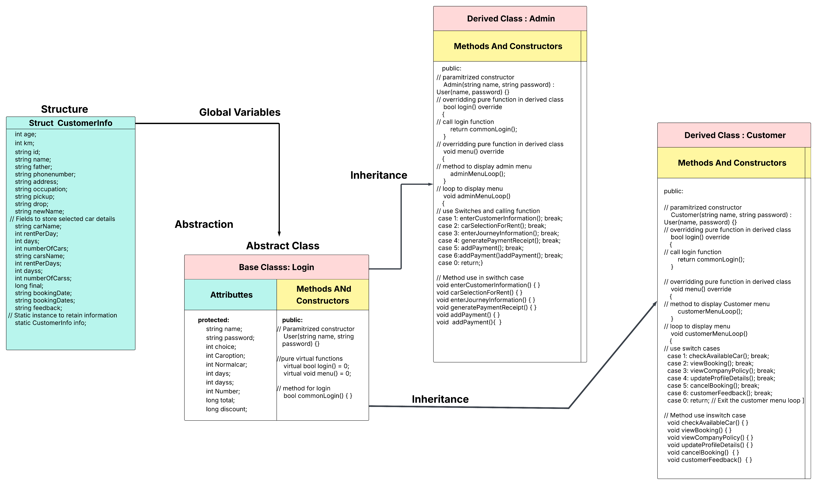

Diagram 2:

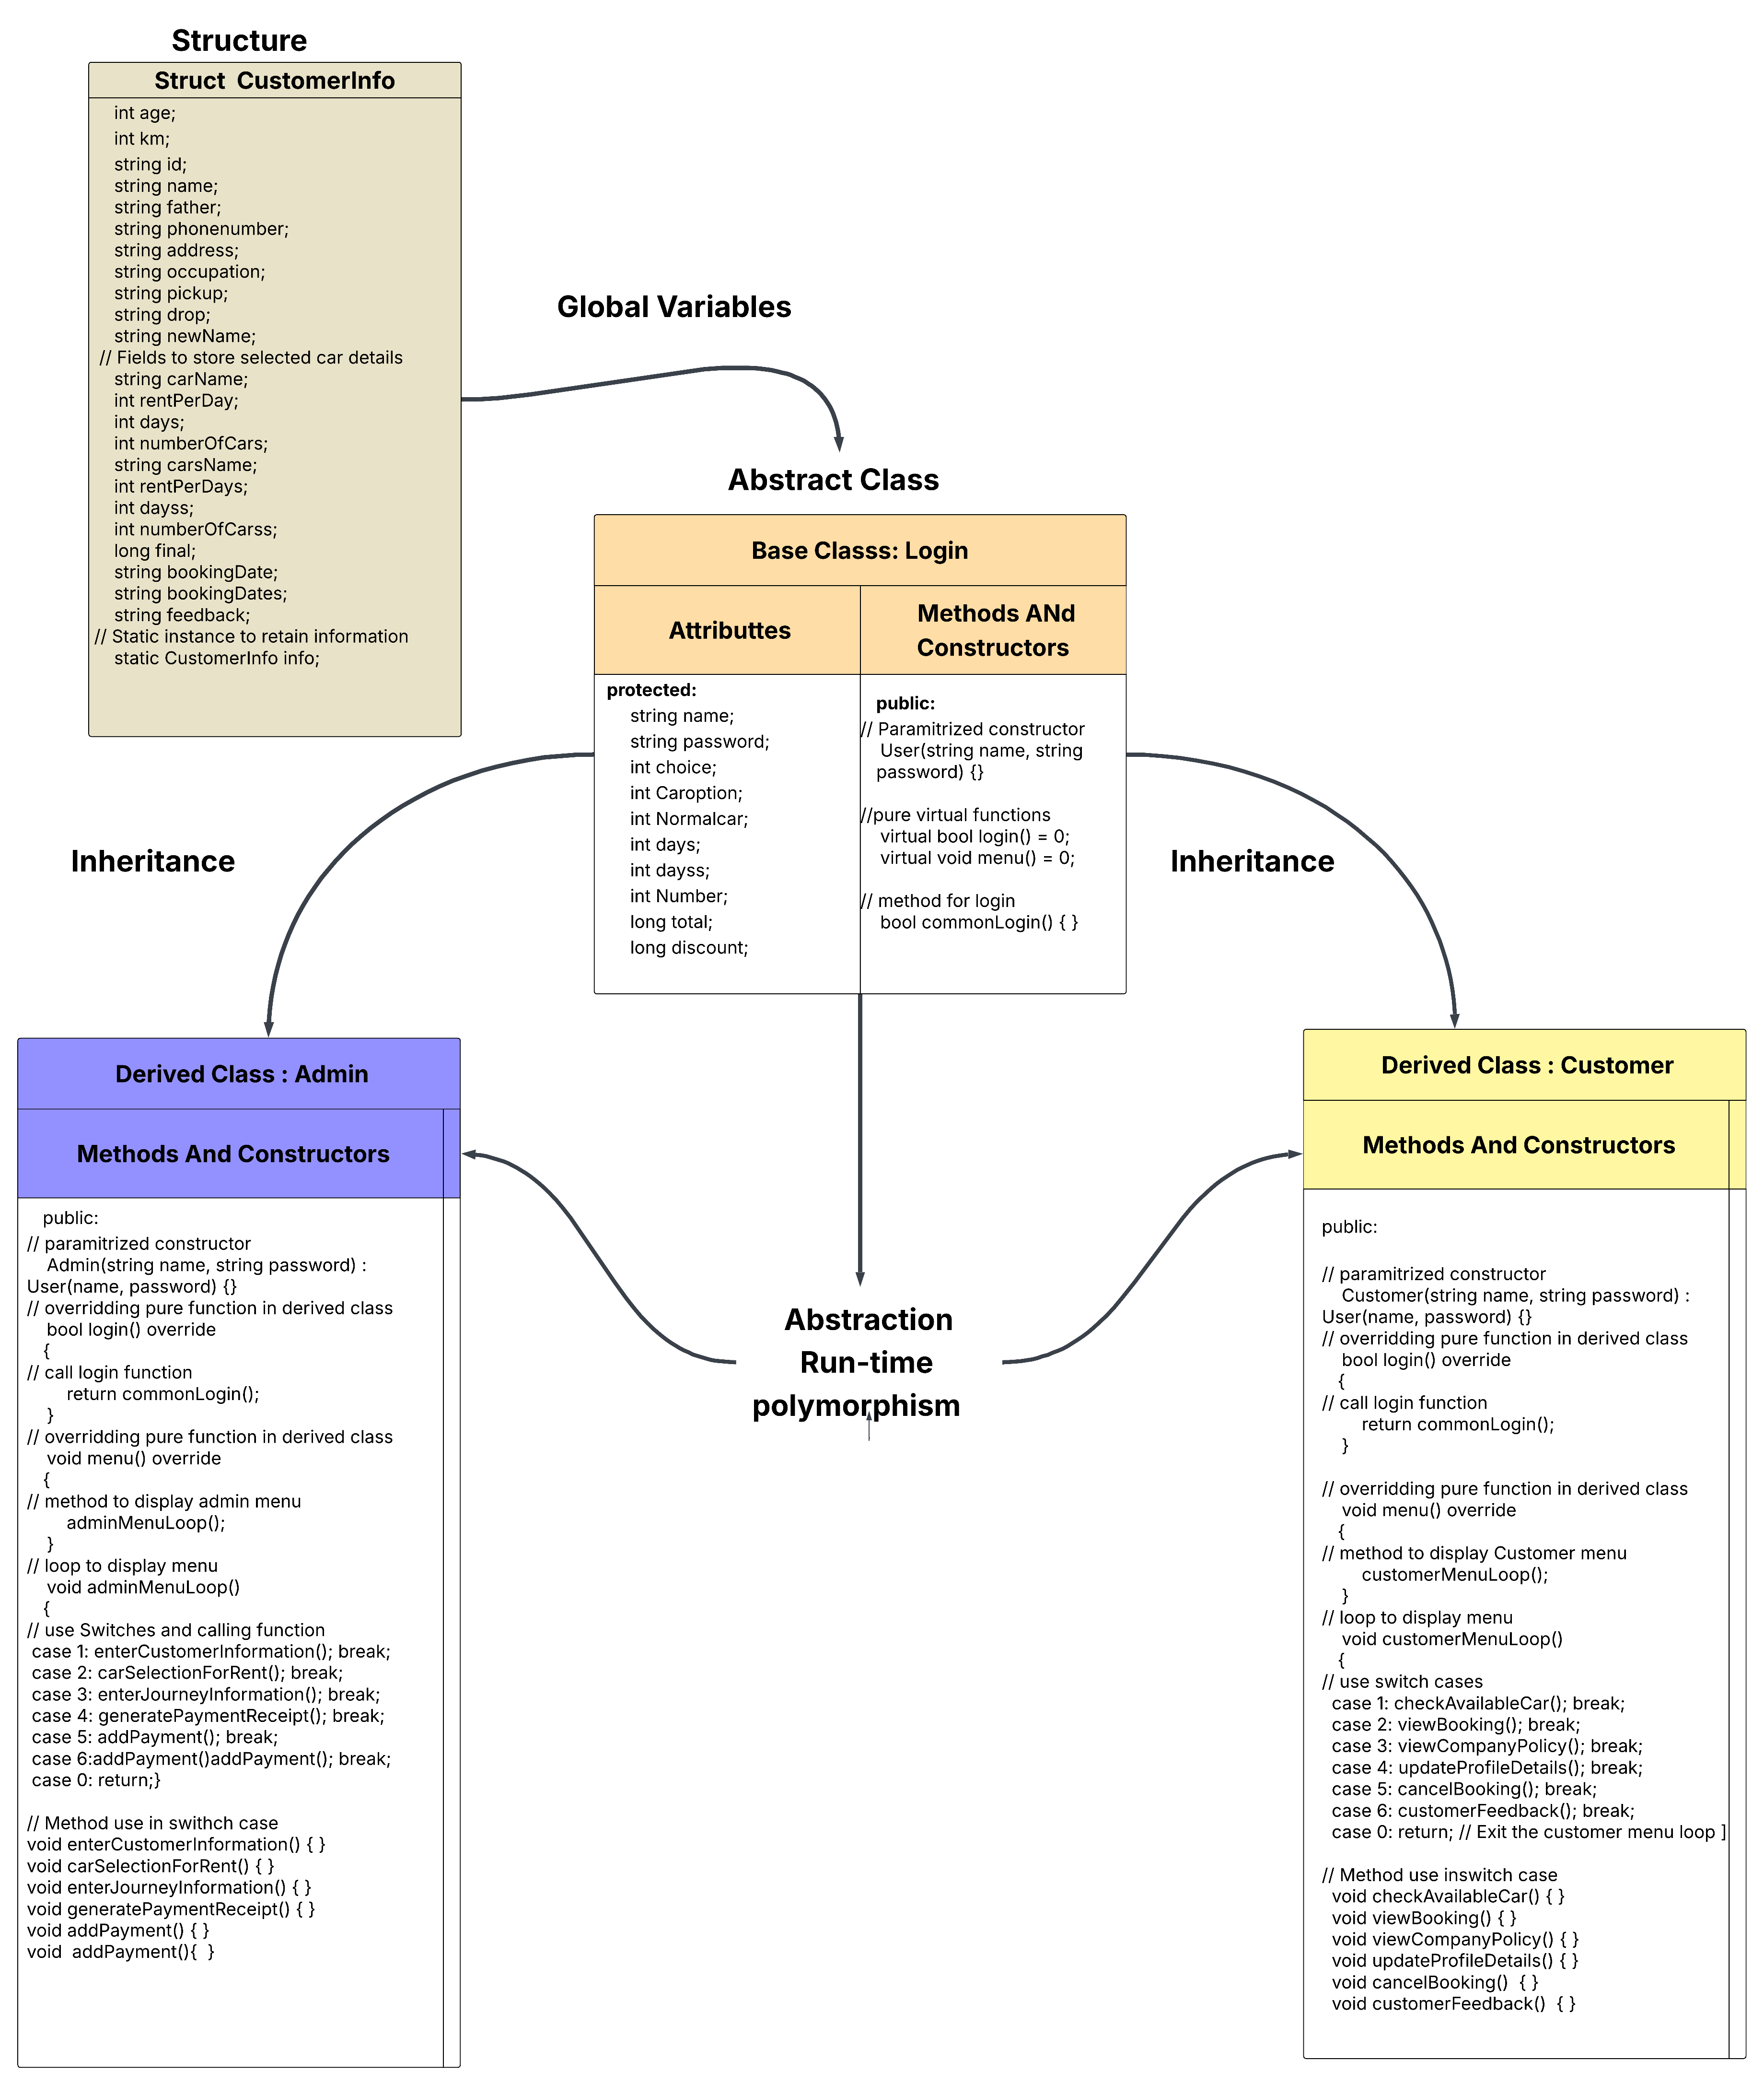

Diagram 3:

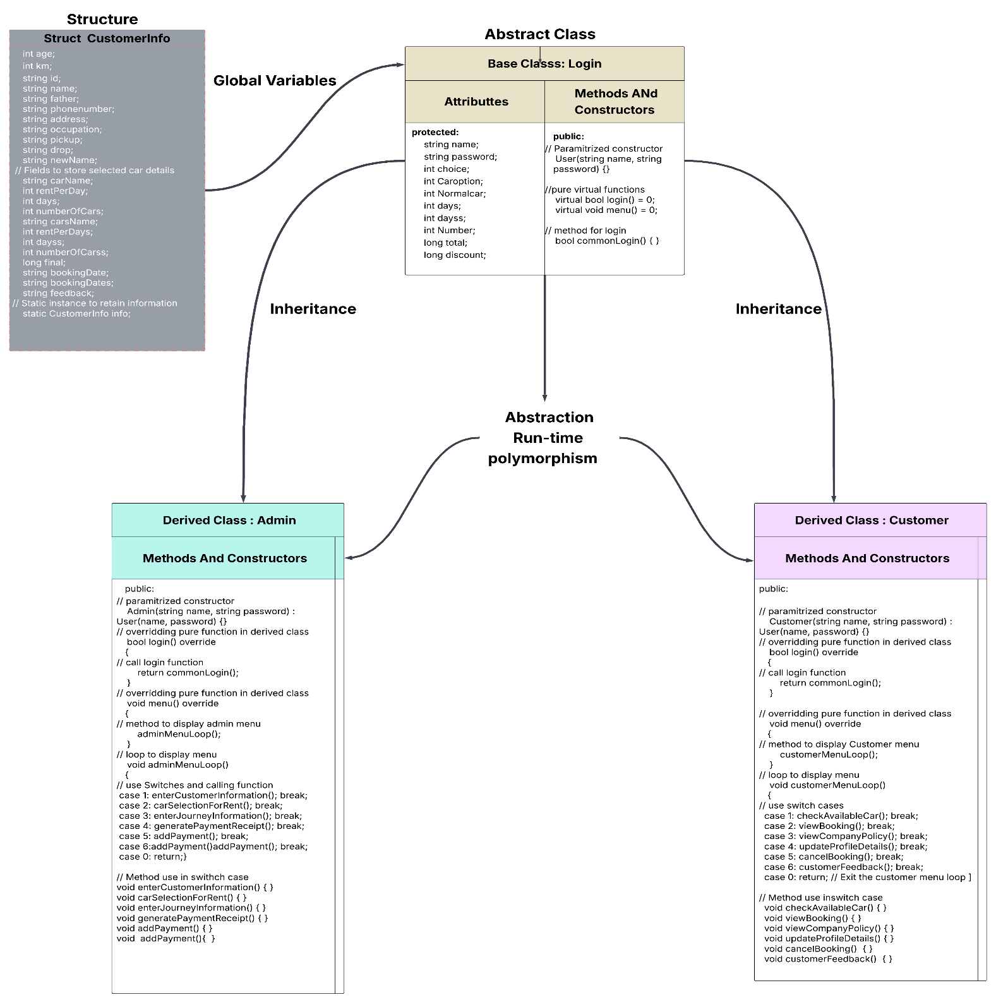

Diagram 4:

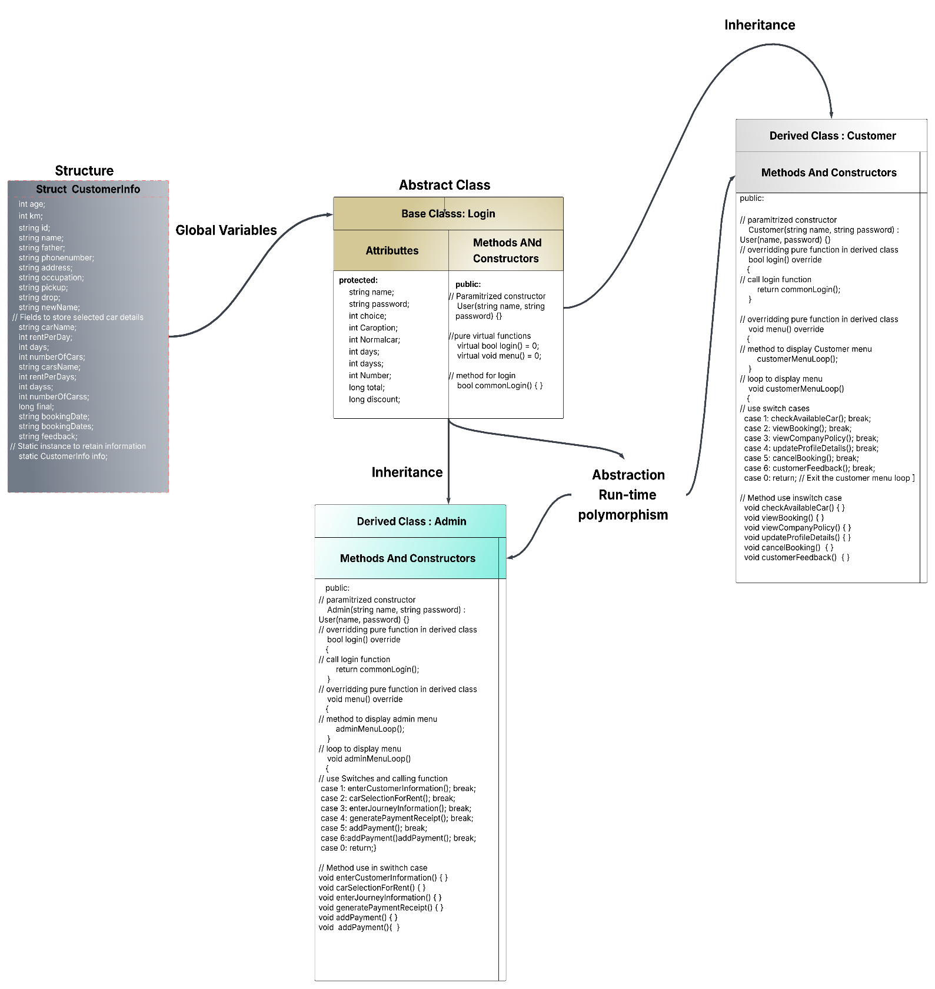

Diagram 5:

